TFS #93833

Allow customer-level reviews to flag accounts that were selected by Scope

Overview

Fix so Lien Position is not defaulted and also display loan position in the Collateral Analysis grid since it is an attribute of the loan to collateral relationship for FCE and Yankee

April Beston

09/14/2016

Table of Contents

TFS #93833 1

Description 2

Testing Notes 2

Screen Shots and Steps Taken 2

# Description

Orig Title: TEST - Ability to Edit Loan Position from Collateral Analysis Screen

BCM 8/5/16 - Original Request: "I’m not sure why it is a requirement for security documents to be linked to collateral when setting loan position since the security document doesn’t play into the loan position. I understand the need for it when setting lien position but FCE doesn’t use that. We also want the ability to set loan position on the collateral analysis screen (already on the enhancement list) and security documents are not on that screen either which is another reason for security documents to not be a requirement for loan position."

FPI Notes/Examples: If lien position is configurable and turned off, then can edit this…otherwise, you should not be able to edit from the collateral analysis screen.

 RJM 8/8/16 -

This was item #39 & #43 from the Collateral Web Enhancements list.

Linked to item #29.

From Bob's comments to EPC:

Rationalization: Productivity concerns, lots of rekeying, causes some service now cases to be created impacting FPI staff as well

Designed Solution: Fix so Lien Position is not defaulted and also display loan position in the Collateral Analysis grid since it is an attribute of the loan to collateral relationship

KPG 9/7/2016 - Loan Position can now be set in FCE and Yankee on the Collateral Analysis screen. This is not configured for other ACAs.

# Testing Notes

TEST - Ability to Edit Loan Position from Collateral Analysis Screen

## Screen Shots and Steps Taken

Test passed: FCE and Yankee have no lien postion available on Collateral View and Loan Position can be set on the Collateral Analysis Screen.

FCE –

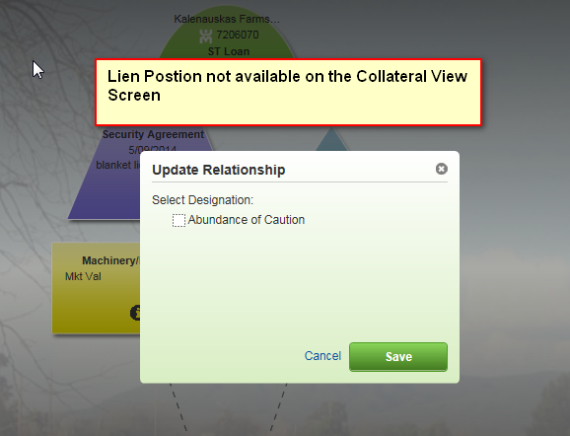

Then on the Collateral Analysis screen, loan position can be set as shown below:

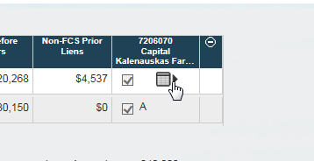

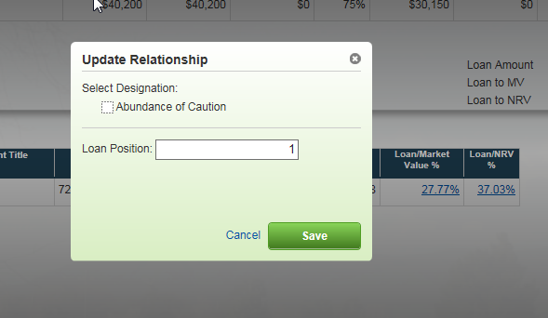

Yankee –

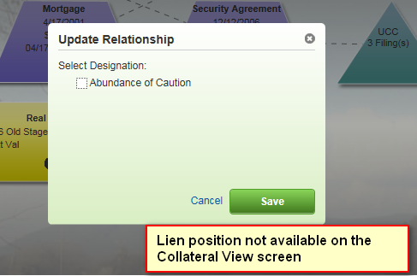

Then on the Collateral Analysis screen, loan position can be set as shown below:

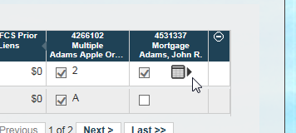

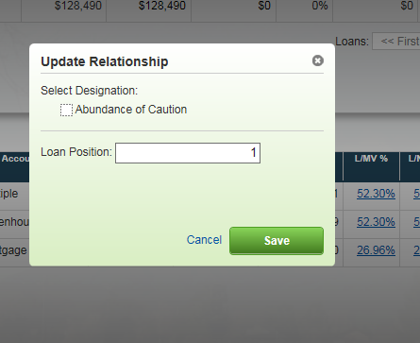

In contrast, FCW has lien postion available on the Collateral View screen:

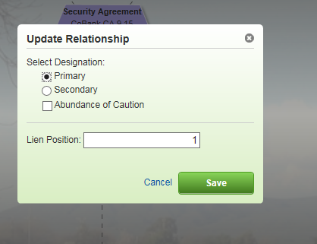

And neither lien nor loan position is accessible from the Collateral Analysis screen:

